1. What is a database?

Sol: Database is a collection of related data that is organized so that it can be easily accessed ,managed and updated.

2. Write about the three main characteristics of a database?

Sol:

* It represents some real world features.
* Data is logical reasonable and meaningful.
* It has a specific purpose planned for users that are interested in its content.

3. For each of the characteristics of a database management system, write why said characteristic matters.

• Access support from remote locations

◦Because some users access the data from any place at any time.

• Data storage, retrieval and update

◦These are the three important functions of database without them database would be useless.

• Support for transactions and concurrency

◦Because the database should be able to handle multiple users request at same time while results of both users after updating their data remain correct.

• User accessible catalog or data dictionary describing the metadata

◦Because database should be opened to user queries

• Enforcing constraints to ensure data in the database abides by certain rules

◦Because if there are certain rules it ensures the predictability of the user queries results which in turn reduced the risk of getting wrong decisions. For example clearing data ensures no one will unwillingly delete the important data

• Support for authorization of access and update of data

◦This is very important because to prevent some private information user must go through authorization.

• Facilities for recovering the database should it become damaged

◦Because there is always a possibility that database can be damaged so there must be some functionality like SQL have start transaction-commit functionality to avoid saving partial data before all operations finished.

• Control of redundancy

◦ Because in database management system all users access the same data from different views. This saves the memory ,prevent having to do multiple updates of the data, and prevents data inconsistency.

• Efficient query processing

◦ Because a DBMS has a special data structures and search techniques to speed up disk search .

4. What are two objectives of a database management system?

1)Support for multiple views of the data:

Different users might request different parts of the data at different time and those parts are provided to them without the need to recode a new program or script every time a new request pops up.

2)Independence between programs and data:

In DBMS programs is written in such a way that if we want to add another piece of data to each specific record we do not need to change any code, we only need to change the description of the records in the catalog to reflect the new data item.

5. These two objectives reached by database management systems both mean that programmers do not have to change programs and scripts. Why?

Sol:

1. As i explained earlier users can request different parts of data at any time and those parts are provided to them without need to recode a new program as different commands exist to get each part of database.
2. programs is written in such a way that if we want to add another piece of data to each specific record we do not need to change any code, we only need to change the description of the records in the catalog to reflect the new data item because in SQL code always remain the same while in other languages like java, code changes after data changes.

For example: command remain same before or after adding columns

SELECT Gpa

FROM STUDENT

WHERE Age >= 20;

For

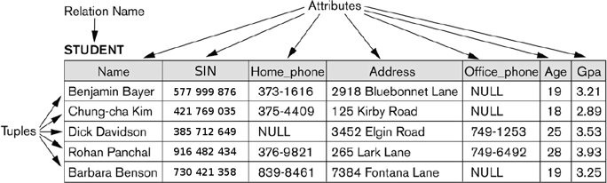

6. According to you, what relation schemas would be appropriate for:

Sol:

• YouTube's database?

* User(Name,Id,Email,PhoneNumber,ChannelName,Playlist,Favourites,Videos,History,Likes,Dislikes,Views,IpAddress)

• Amazon's database?

* User(Name,Id,Email,PhoneNumber,Cart,Orders,History,Comments,Favourites)

• Are there any similarities between the relation schemas that you came up with for both websites?

* These are some similarities both have Name,Id,Email,PhoneNumber,History,Favourites etc.

7. Give examples of systems in which it may make sense to use traditional file processing instead of a database approach.

Sol:Any application that is used by single user does not require security so instead of DBMS we can use traditional file processing for example personal address.

8. For the above database:

• Identify some informal queries and update operations that you would expect to apply.

* Queries:1.List the names of the students having course Discrete Mathematics

2.What is the Student_number of student name Brown.

* Updates:1.Insert a new student having Name=Kharoud,Class=3,Major=Math.

2.Change the Class of student name=Smith into 3.

• Specify all the relationships among the records.

* Section is related to Course_number in COURSE record.
* Grade_Report is related to Section record as well as Student record.
* Prerequisite is related to Course record.

•If the name of the ‘CS’ (Computer Science) Department changes to ‘CSSE’ (Computer Science and Software Engineering) Department and the corresponding prefix for the course number also changes, identify the columns in the database that would need to be updated.

* Major column in Student
* Course_number and department column in Course record
* Course_number column in Section department
* Course_number and prerequisite column in Prerequisite record.

• Can you restructure the columns in the COURSE, SECTION, and PREREQUISITE tables so that only one column will need to be updated?

Sol:we can split the column in COURSE, SECTION, and PREREQUISITE tables.